Asset Criticality
Determining asset criticality is a portion of the first step in the R&R for Highways process, “Asset Characterization”. Criticality is a measure of the importance of an asset to the resilience of the system and the success of CDOT to carry out its mission of delivering service to its travelers. Criticality is therefore not a measure of the cost of an asset, nor the likelihood an asset may fail in response to a hazard; these asset characteristics are captured in other parts of the R&R for Highways analysis framework.
There are two primary reasons for determining asset criticality. First, no agency has sufficient resources to bring every asset to the highest standard to withstand every hazard and magnitude of hazard. For example, it is not cost effective to build a rockshed for entire length of Glenwood Canyon, approximately 12.5 miles, as a measure to mitigate rockfall. Rather, CDOT has utilized rock netting, rock fences, and other mitigation measures at locations with high probability of significant rockfall and potential damage to the roadway and other assets. Second, understanding the relative criticality of all assets in the CDOT system is necessary if one is to evaluate risk for any asset and hazard in the context of CDOT’s entire transportation network and mission. This information makes it possible to weigh mitigation alternatives, to know where emergency response plans are most urgently needed, and to identify alternate routes that should be examined for improvement should a critical link be highly susceptible to failure.
Over the course of the Pilot project, the WG and EOC collectively developed an asset criticality model. Over nine iterations of the model with various criteria, weights of criteria, etc., were developed for consideration by the WG and EOC. Ultimately, six criteria were included in CDOT’s objective model of Asset Criticality, as indicated in Table 2.
Table 2. Final CDOT Asset Criticality Model for System Resilience
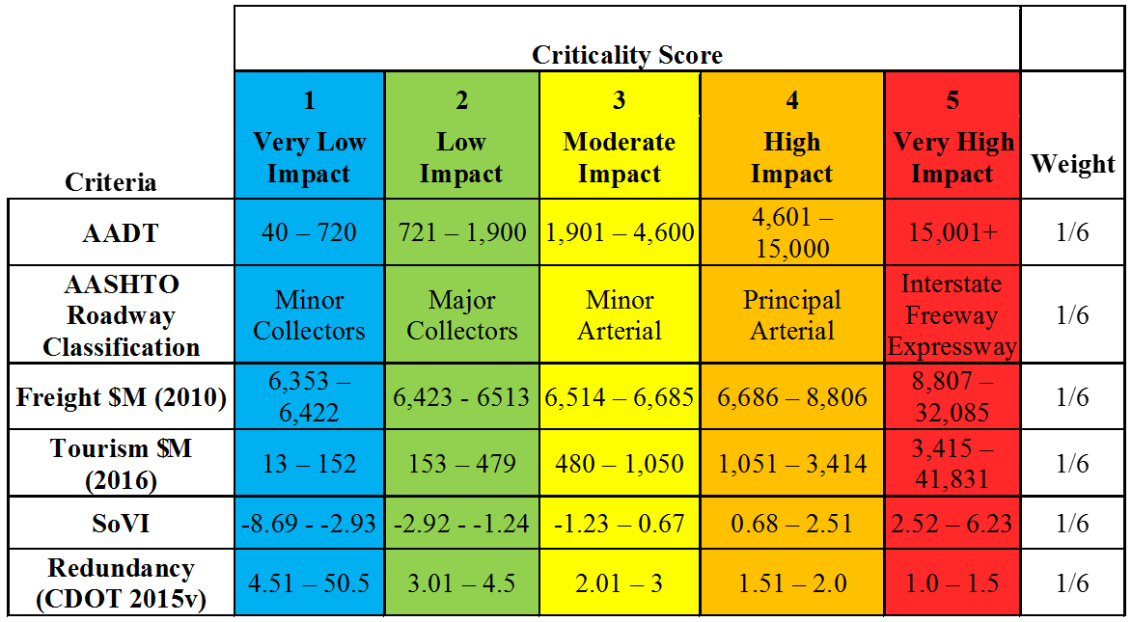
The criteria included in the model, as shown in Table 2, include Average Annual Daily Traffic (AADT); the Association of American State Highway and Transportation Officials (AASHTO) Roadway Classification factor; Freight value per Ton at the county level in millions of dollars per year; Tourism dollars generated at the county level in millions of dollars per year (Colorado Tourism Office June 2015 Report); Social Vulnerability Index (SoVI) at the county level (University of South Carolina Hazards & Vulnerability Research Institute 2010-2014); and system Redundancy. The criteria were suggested by the Consultant Team and various versions of the model with a range of criteria and weights were considered by the WG and the EOC. Ultimately the criteria shown in Table 2 were selected as the WG and the EOC believed that this version of the model best represent three pillars of system resilience including: environmental, social, and economic impacts to the citizens of Colorado.
The criticality score was derived by summing the six criteria. This score was then appended to all assets (i.e., bridge, pavement prism, culvert, wall) between pairs of mile points for each roadway. Roadways were grouped into Low-, Moderate-, and High-Criticality by setting criticality score cut-offs so that approximately 50% of centerline miles were ranked as Low-Criticality, 25% ranked as Moderate-Criticality, and 25% of centerline miles were ranked as High-Criticality. The Criticality score was also assessed for distributional equity across CDOT Engineering Regions. Table 3 indicates the results of the final Asset Criticality Model, as expressed in percent of centerline miles statewide.
Table 3. Criticality as a Percent of Centerline Miles by Region
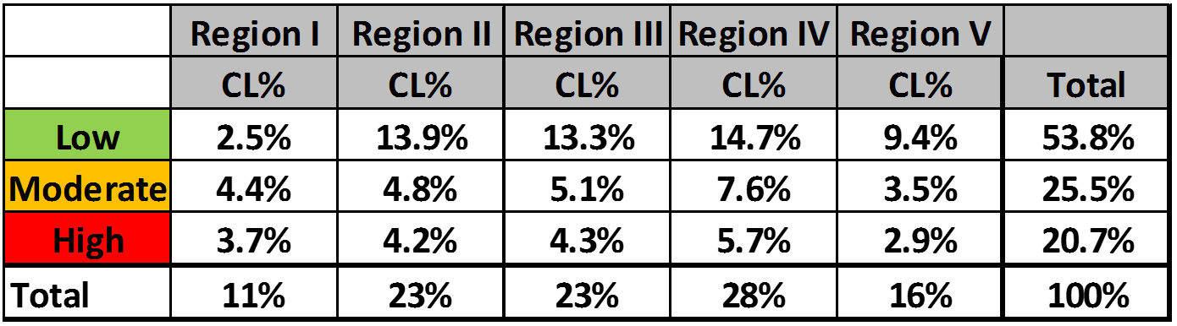
Several reviews of the resulting criticality scores were conducted with members of the WG, the EOC, the CDOT Commission, and CDOT regional staff. Many discussions ensued as to the potential use of the resulting criticality and it should be noted that the purpose of the ranking is simply to reflect those assets of the CDOT system that are important to the capability of CDOT to provide system resilience and allow for movement of travelers across the state. Figure 7 is a map of CDOT asset criticality by CDOT Region. Red indicates assets rated High-Criticality; brown-orange indicates assets of Moderate-Criticality. Low-Criticality assets are represented in green.

Figure 7. CDOT Asset Criticality Map for System Resilience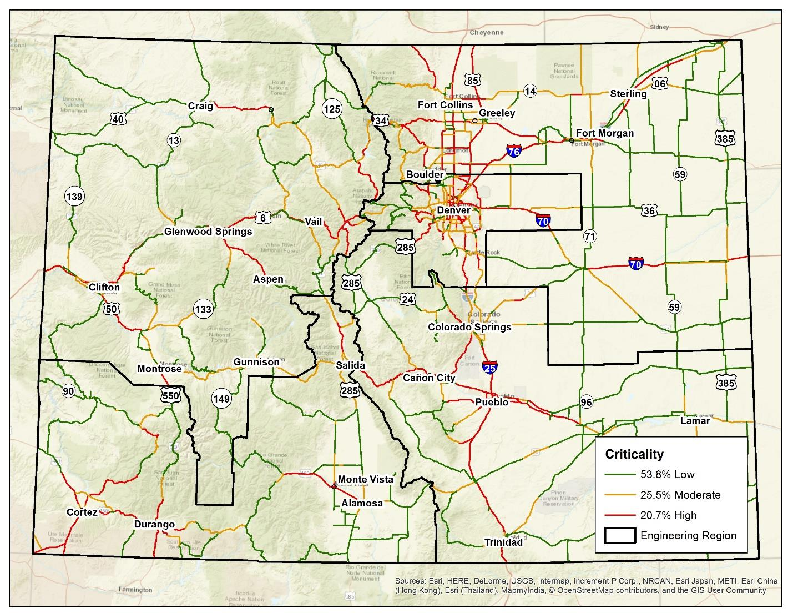

For the I-70 facility, the interstate was broken into logical on and off points of the facility onto CDOT owned and operated facilities. For each of these segments, known as resilience segments, the criticality for system resilience metric was also calculated and is shown in Figure 8.

Figure 8. Resilience Segments for I-70 and Criticality Score for System Resilience
